Serratus Results 2.0
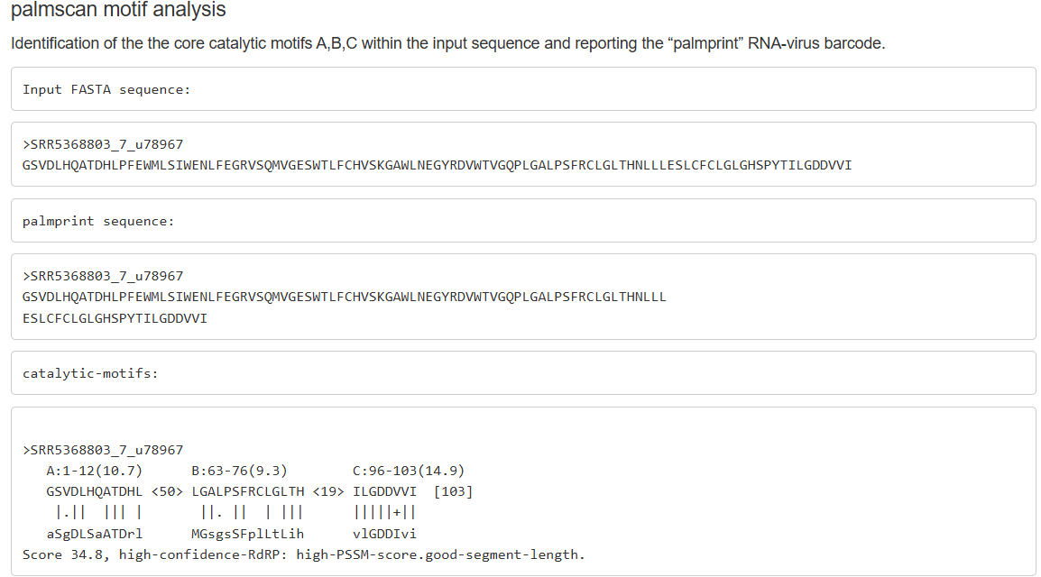
Palmprint analysis using Serratus identified the catalytic motifs A, B, and C within the recovered 103-aa RdRp palmprint sequence, with coordinates A:1–12, B:63–76, and C:96–103. The palmprint (PalmID u78967) achieved a score of 34.8, classifying it with high confidence as a member of the Lenarviricota RdRp clade. Palmprint alignment showed 76–77% identity to Orin narna-like virus, indicating that this represents a novel species within the Narnaviridae/Mitoviridae lineage, typically associated with fungal hosts.

